CAS PY 106

In-Class Note 2

1. Electric Force Between Charged Objects
2. Two charged objects, of charge q1 and q2, separated by a distance r, exert a force on one another. The magnitude of the force is

Coulomb’s Law : F12 = k\*q1\*q2/r^2 where k = 8.99 \*10  
^9 N \*m^2/C^2

F12 means the magnitude of the force exerted BY charge 1 on charge 2

1. The force is attractive if the charges are opposite polarity (+/-)
2. The force is repulsive if the charges are the same polarity (+/+ or -/-)
3. Newton’s Universal Law of Gravitation
4. F = Gm1m2/r^2 is similar to Coulomb’s Law
5. G (constant) is much smaller than the constant k on Coulomb’s Law
6. Therefore, the electric force is much stronger than gravity
7. Force Between Charged Objects
8. R and F have inverse relationship
9. If we decrease the distance between charges by a factor of 2, F increases by a factor off 4
10. 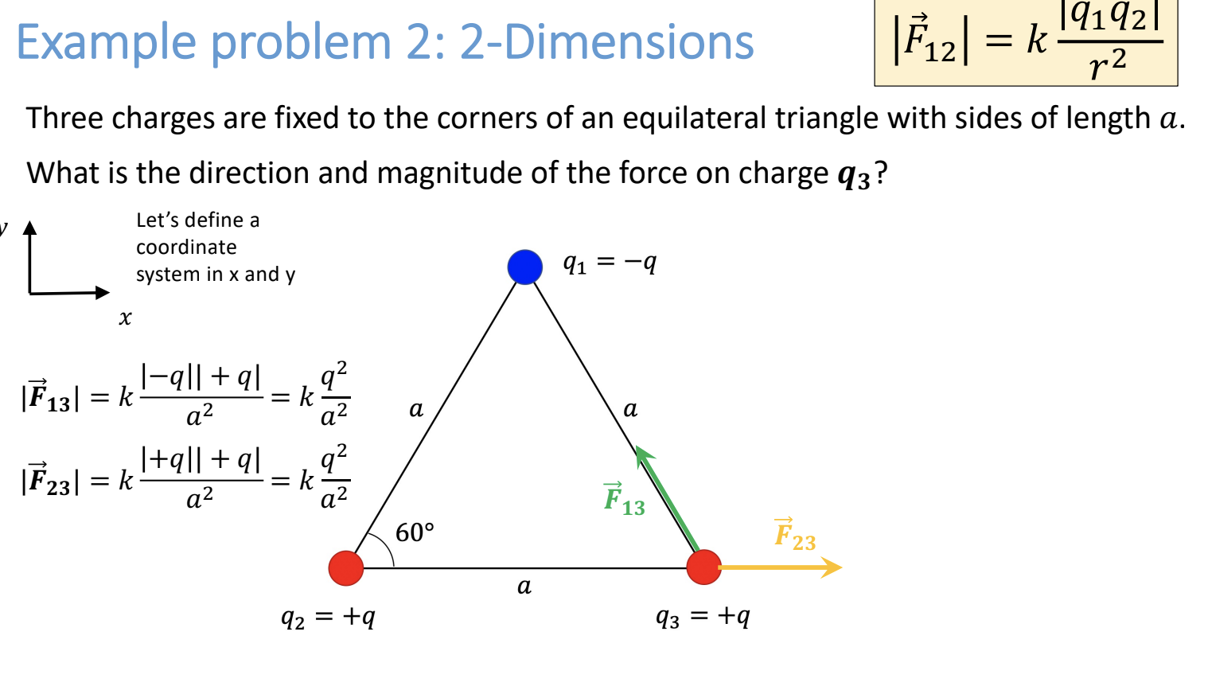
11. Force Between “Point” Charges
12. For simplicity, we stick to simple objects like point charges
13. Point charges are ideal point-like objects with no spatial dimensions (ignore size of an object)
14. Small distance 🡪 large force while large distance 🡪 small force
15. Lots of charge 🡪 large force while not much charge 🡪 small force
16. Signs of charge 🡪 direction of force
17. Superposition – more than two point charges
18. If an object experiences more than one force, we can use The principle of Superposition
19. The net force on an object is vector sum of the individual force on an object is the vector sum of the individual forces acting on that object
20. This means we can consider each pair of forces, one at a time, and then add them all up
21. 